GUI Documentation

Desktop Application

Startup:

The following screenshot displays the user interface upon the program’s startup. The user sees a message log to gauge message transfer speed (this is to be removed later and is strictly for developer use). The user also sees a window with the Stream2Me heading and two fields requesting information that will be used to log them into the system.

To progress, the user enters their e-mail address and a password, then presses Login.

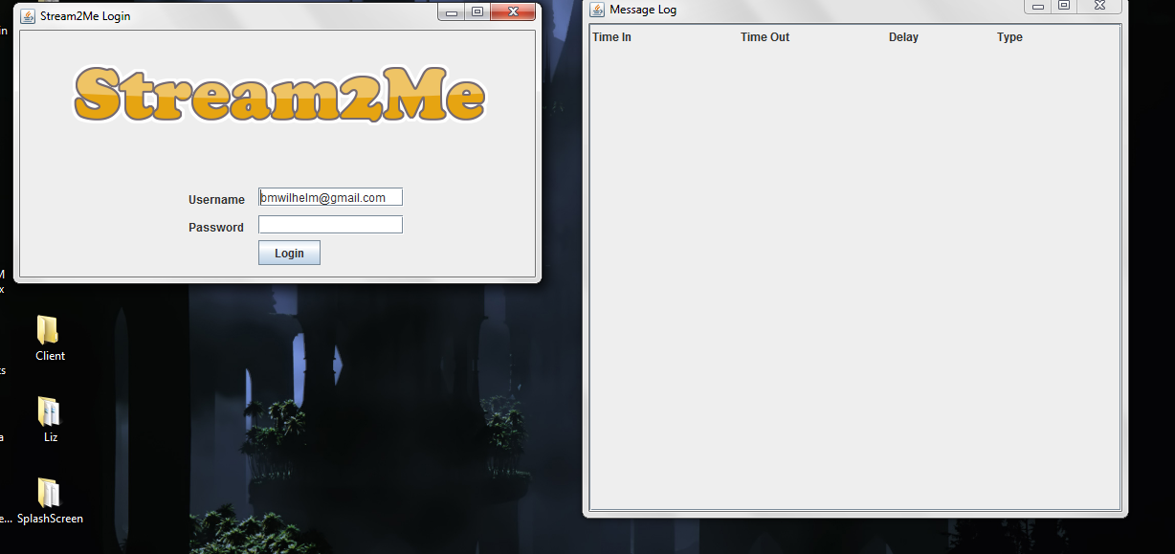

(Figure 1: Desktop application startup screen)

Using the Application:

After the initial startup phase, the user will be directed to the window seen below. This is the client-side interface and is what the user will be making use of when connecting to people, receiving, and transferring media and other types of data.

Underneath the user’s profile image are two buttons marked with a camera and a microphone. By pressing these buttons, the user is able to stream audio and video feeds in real-time to their selected recipient in their list of contacts they are connected to (as seen below the profile pane, at the bottom left side of the window).

Text messages may be sent as well, by selecting a recipient and entering the text in the field at the bottom of the window and selecting to send it with the button to the right of the text area.

The message log will track the times at which items were sent and received and determine the delay between transmission and reception of that specific message. It lists the times that the message was sent, the time it was received, and the message type in addition to the delay in seconds.

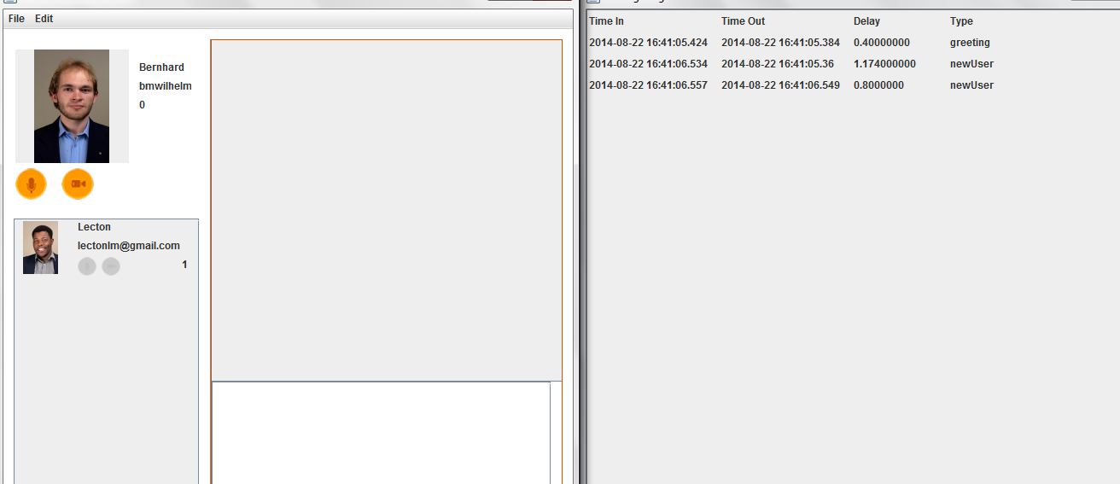

(Figure 2: Client-to-client communication interface)

Streaming:

If the user elects to stream video data, he/she can do so by selecting the video button, which will then proceed to record and transmit their desktop image in real-time, frame by frame. This allows the recipient to see what the sender is working on in real-time and plays to them as a vide would, in the display pane that appears on the right of the screen, as seen on the screenshot below.

In much the same way, the user can transmit speech or other sound by selecting the audio streaming button and speaking into the microphone, or playing the selected medium on their own computer.

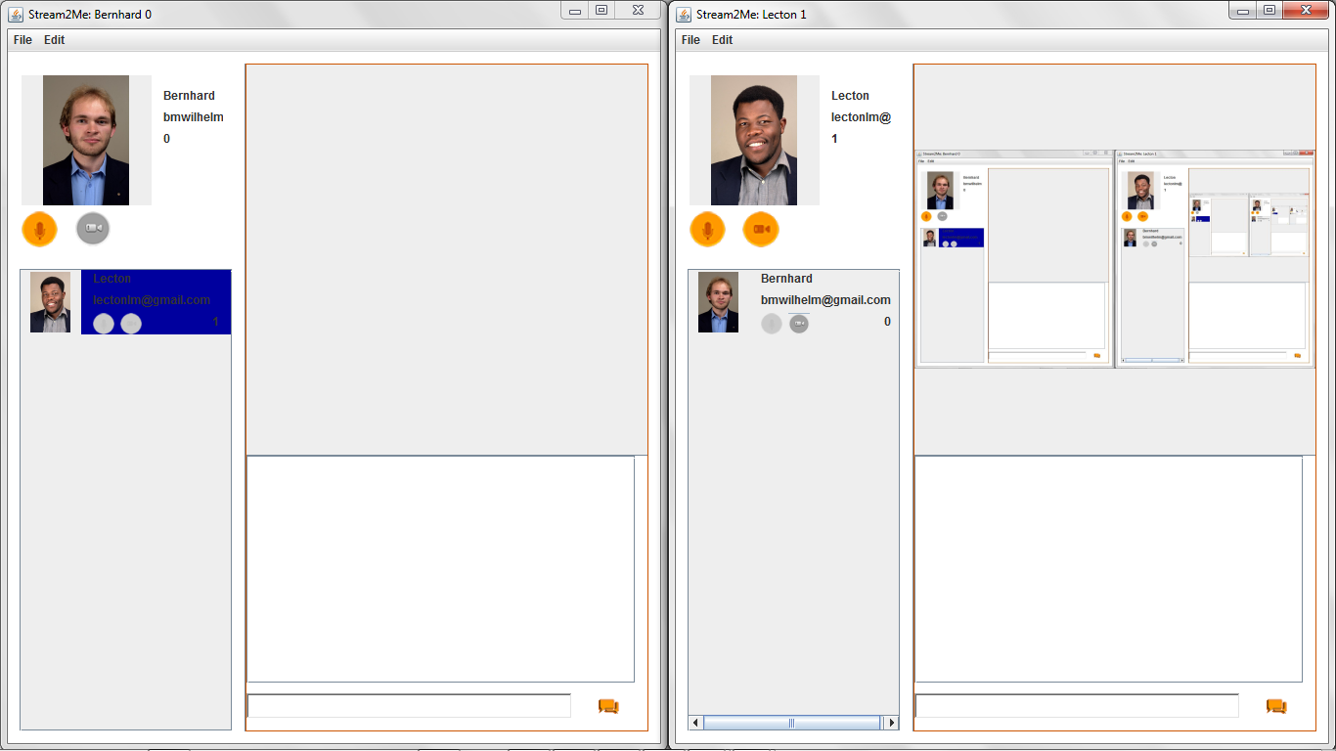

(Figure 3: Video/audio streaming interface)

Mobile Application

Startup:

For the most part, the mobile interface works exactly the same as the desktop interface.

Seen below, the user encounters the login screen which prompts them for their credentials and if successful, logs them into the system where they will be able to peform the same actions that are available to them in the desktop version of the application.

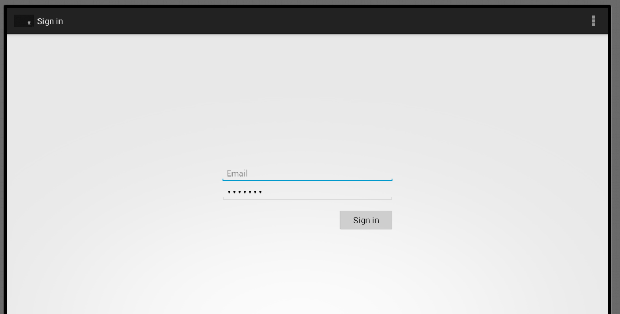(Figure 4: Android login screen)

Using the Android Application:

After the user has entered their information, and their infrmation has been verified, the user will be directed to the screen seen below. This is the client-side interface and is what the user will be making use of when using the mobile application and will allow the user to connect to people, receive, and transfer media and other types of data.

Underneath the user’s profile image are three buttons marked with a camera icon, a microphone icon, and a broadcast icon. By pressing these buttons, the user is able to stream audio and video feeds in real-time to their selected recipient in their list of contacts they are connected to (as seen below the profile pane, at the bottom left side of the window). By pressing the broadcast button, they broadcast a message that encompasses both audio and video data.

Text messages may be sent as well, by selecting a recipient and entering the text in the field at the bottom of the window and selecting to send it with the button to the right of the text area.

The list of recipients grows as more clients conect to the system and the user may select any persons from that list who they wish to stream to, as indicated in Figure 6.

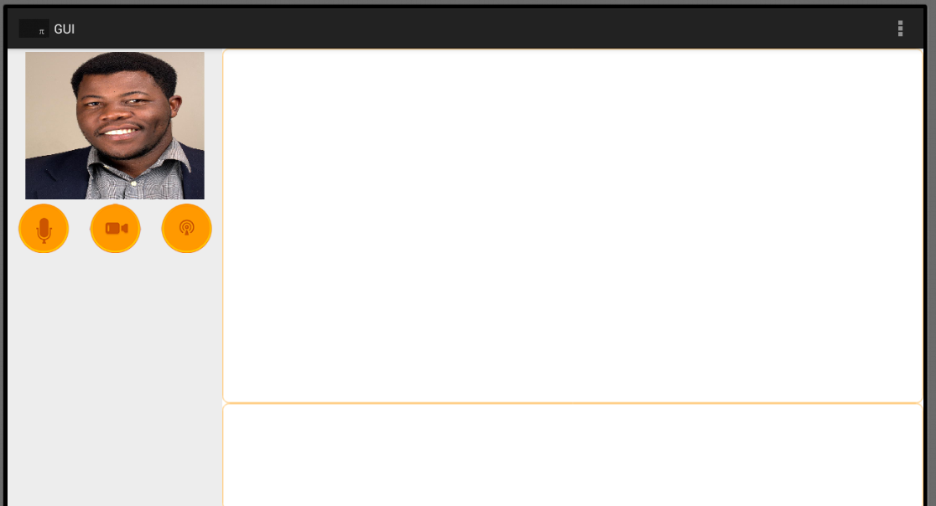

(Figure 5: The client interface)

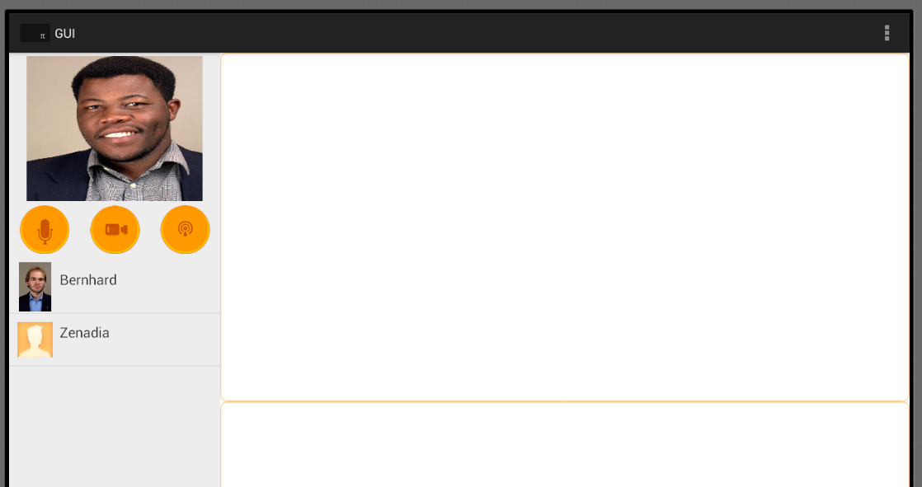

(Figure 6: Client interface and contact list)

Streaming:

Streaming for the mobile application works in much the same way as it does for the desktop application. If the user elects to stream video data, he/she can do so by selecting the video button, which will then proceed to record and transmit their desktop image in real-time, frame by frame. This allows the recipient to see what the sender is working on in real-time and plays to them as a vide would, in the display pane that appears on the right of the screen, as seen on the screenshot below. If the user wishes to stream both audio and video data at once, they can select the broadcast button.

In much the same way, the user can transmit speech or other sound by selecting the audio streaming button and speaking into the microphone, or playing the selected medium on their own device.

